 | Al-Rafidain Journal of Engineering Sciences |  | 
 | Journal homepage https://rjes.iq/index.php/rjes
Highly dispersive optical solitons with cubic law and cubic-quintic-septic law nonlinearities by two methods

Anwar Jaafar Mohamad Jawad^{1,*} , Mahmood Jawad Abu-AlShaeer²

¹Department of Computer Technical Engineering, Al Rafidain University College, 10064 Baghdad, Iraq
anwar.jawad@ruc.edu.iq
² Al Rafidain University College, 10064 Baghdad, Iraq
mahmood.jawad@ruc.edu.iq
ARTICLE INFO |  | ABSTRACT
Article history:  Received 2 August 2023  Revised 3 August 2023  Accepted 7 August 2023  Available online 10 August 2023 |  | In this paper, the Csch technique, Sine-Cosine strategy are utilized to recover the new particular optical solitons for exceptionally dispersive dispersive Nonlinear Schrodinger Equation NLSE. These plans really get the specific arrangement of the model as dim, particular, solitary occasional and splendid particular combo optical solitons. These arrangements help the mathematicians to understand the actual peculiarities of present model. The arrangements in presents work demonstrate that these plans offer us a powerful numerical device for addressing NLSEs in different areas of applied sciences. These plans actually procure the specific arrangement of the model as dim, solitary, particular intermittent and splendid particular combo optical solitons. The arrangements in presents work demonstrate that these plans offer us a persuasive numerical device for tackling NLSEs in different areas of applied sciences.
Keywords:
Solitary wave solutions
Csch method
Sine-Cosine method
Highly dispersive solitons

- Introduction

The NLS condition assumes a significant part in the demonstrating of a few actual peculiarities, for example, the spread of optical heartbeats, waves in liquids and plasma, self-centring impacts in lasers, and catching of nuclear gas in Bose-Einstein condensates.
Optical solitons have been analysed in many fields as hypothetical material science, applied math, plasmas, compound physical science, optical strands, thermodynamics wave spread and nonlinear optics. Whenever scattering terms overwhelm, these solitons convert to profoundly dispersive optical solitons [1-10].
Two techniques give the arrangement in a fast concurrent series with calculable terms. These techniques were effectively applied to nonlinear differential conditions. Various adjustments to address nonlinear differential conditions are given in [11-12].
The alterations emerge from assessing hardships explicit for the sort of issue viable. The adjustment as a rule includes just a slight change and is pointed toward working on the intermingling or exactness of the arrangement. The principal objective of this paper is to apply a few changes of the three techniques to the nonlinear Schrödinger's condition and contrast the outcomes and the specific arrangements.

- The Governing Equations

In this work, we manage solitons when higher request scattering terms (3OD, 4OD, 5OD and 6OD terms) act other than of the standard GVD. In such circumstances, the administering NLSE performs having six scattering terms.

2.1. Cubic-quintic-septic law
$iq_{t}+ia_{1}q_{x}+a_{2}q_{xx}+i a_{3}q_{xxx}+a_{4}q_{xxxx}+ia_{5}q_{xxxxx}+a_{6}q_{xxxxxx} +\left(c_{1}{\left\lfloor q\right\rfloor }^{2}+c_{2}{\left\lfloor q\right\rfloor }^{4}+c_{3}{\left\lfloor q\right\rfloor }^{6}\right)q=0$ (1)
For more detail see [7,10].

2.2. Cubic nonlinearity
$iq_{t}+ia_{1}q_{x}+a_{2}q_{xx}+ia_{3}q_{xxx}+a_{4}q_{xxxx}+ia_{5}q_{xxxxx}+a_{6}q_{xxxxxx} +i [d_{1}{\left({\left\lfloor q\right\rfloor }^{2}q\right)}_{x}+d_{2}{\left({\left\lfloor q\right\rfloor }^{2}\right)}_{x}q+d_{3}{\left\lfloor q\right\rfloor }^{2}q_{x}]=0$ (2)
For description of above model see [1,3,11].

- Travelling wave solution
For the arrangement of profoundly dispersive optical solitons with cubic and cubic-quintic-septic (CQS) regulation nonlinearities to track down the dim, solitary, particular occasional and brilliant particular combo solitons in (1) and (2), The arrangements might be assumed as
$q\left(x,t\right)= u\left(ξ\right) e^{i θ(x,t)}$ (3)
Where $ξ= x-γ t$ and the phase $θ(x,t)=-kx+ω t+ θ_{0}$ , u($ξ$) is the amplitude component of the wave and $γ$ is its speed. k is the soliton frequency; ω is its wavenumber and $θ_{0}$ is the phase constant
$q_{t}=e^{i θ}\left[-γ u^{'} +i ω u\right]$
$q_{x}=e^{i θ}[ u^{'}-k i u]$
$q_{xx}=e^{i θ}\left[ u^{''}-2 k i u^{'}-k^{2} u\right]$
$$q_{xxx}=e^{i θ}\left[ u^{(3)}-3 k i u^{''}-3k^{2} u^{'}+ik^{3} u\right]$$
$$q_{xxxx}=e^{i θ}\left[ u^{(4)}-4 k i u^{(3)}-6k^{2} u^{''}+4ik^{3} u^{'}+k^{4} u\right]$$
$$q_{xxxxx}=e^{i θ}\left[ u^{(5)}-5 k i u^{(4)}-10k^{2} u^{(3)}+10 ik^{3}u^{''}+5k^{4} u^{'}-i k^{5} u\right]$$
$q_{xxxxxx}=e^{i θ}\left[ u^{(6)}-6 k i u^{(5)}-15k^{2} u^{(4)}+20 ik^{3}u^{(3)}+15k^{4} u^{''}-6 i k^{5} u^{'}-k^{6} u\right]$ (4)

3.1. Cubic-quintic-septic law
Eq. (1) can be disintegrating into real and imaginary parts yields a pair couple of relations.
The real and imaginary parts of Eq. (1) respectively are:
$-\left[ ω-a_{1}k+a_{2}k^{2}+a_{3}k^{3}-a_{4}k^{4}-a_{5} k^{5}+a_{6}k^{6} \right] u+c_{1}u^{3}+c_{2}u^{5}+c_{3}u^{7}+a_{6} u^{(6)}+\left[a_{4}+5a_{5} k -15a_{6}k^{2} \right]u^{(4)}+\left[a_{2}+3a_{3} k -6a_{4}k^{2} -10a_{5}k^{3}+15a_{6}k^{4} \right]u^{''} =0$ (5)
and
$\left[γ-a_{1}+2 a_{2}k+3a_{3}k^{2}-4a_{4}k^{3}-5a_{5}k^{4}+6 a_{6}k^{5} \right] u^{'}-\left[a_{3}-4a_{4} k -10a_{5}k^{2}+20a_{6} k^{3} \right]u^{\left(3\right)}-\left[ a_{5}-6 k a_{6}\right] u^{(5)}=0$ (6)
We can easily obtain following constraint conditions from (6)
$a_{3}=4k\left(a_{4}+10 a_{6} k^{2}\right)$ (7)
$a_{5}=6 k a_{6 }$ (8)
Soliton speed takes the form
$γ=a_{1}-2 k\left(a_{2}+4 a_{4}k^{2}+48 a_{6} k^{4}\right)$ (9)
So, reduced equation of the real part becomes
$-\left[ ω-a_{1}k+a_{2}k^{2}+3a_{4}k^{4}+35a_{6}k^{6} \right] u+c_{1}u^{3}+c_{2}u^{5}+c_{3}u^{7}+a_{6} u^{(6)}+\left[a_{4}+15a_{6}k^{2} \right]u^{(4)}+\left[a_{2}+6a_{4}k^{2}+75a_{6}k^{4} \right]u^{''}=0$
(10)
3.2. Cubic nonlinearity
Using Equation (3) and their derivatives in (4), equation (2) can be decomposing into real and imaginary parts yields a pair of relations.
The real and imaginary parts of Eq. (2) respectively are:

$-\left[ ω-a_{1}k+a_{2}k^{2}+a_{3}k^{3}-a_{4}k^{4}-a_{5}k^{5}+a_{6}k^{6}\right] u+\left[a_{2} +3 a_{3}k-6a_{4}k^{2}-10 a_{5}k^{3} +15a_{6}k^{4} \right] u^{''}+\left[a_{4} +5a_{5} k-15a_{6}k^{2} \right] u^{\left(4\right)}+a_{6} u^{\left(6\right)}+\left(d_{1}+d_{3}\right) k u^{3}=0$
(11)
and
$\left[-γ +a_{1}-2 ka_{2}-3 a_{3}k^{2} +4a_{4}k^{3} +5a_{5}k^{4} -6 a_{6} k^{5} \right] u^{'}+\left[a_{3}-4a_{4} k-10 a_{5} k^{2}+20a_{6} k^{3}\right] u^{(3)}+\left[ a_{5}-6a_{6} k \right]u^{(5)}+\left[3 d_{1}+2 d_{2}+d_{3}\right] u^{2} u^{'}=0$
(12)
So that the constraint conditions from (12)
$d_{3}=-3 d_{1}- 2 d_{2}$ (13)
$a_{3}=4k \left(a_{4} +10 a_{6} k^{2}\right)$ (14)
$a_{5}=6 k a_{6 }$ (15)
Soliton speed takes the form
$γ=a_{1}-2 k\left(a_{2}+4 a_{4}k^{2}+48 a_{6} k^{4}\right)$ (16)
So, the reduced real part equation becomes:
$-\left[ ω-a_{1}k+a_{2}k^{2}+3 a_{4}k^{4}+35 a_{6}k^{6}\right] u+\left[a_{2} +6a_{4}k^{2}+75 a_{6}k^{4} \right] u^{''}+\left[a_{4} +15a_{6}k^{2} \right] u^{\left(4\right)}+a_{6} u^{\left(6\right)}-2k\left(d_{1}+d_{2}\right) u^{3}=0$
(17)
- Methodology

In this section we will apply three different methods to solve eqns. (10) and (17). These methods are Csch method, Sine-Cosine method.

4.1. Csch function method
The solutions of many nonlinear equations can be expressed in the form [11]:
$V\left(ξ\right)=A {csch}^{τ}\left(μ ξ\right)$ (18)
and their derivative.
$V^{'}\left(ξ\right)=- A τ μ {csch}^{τ}\left(μξ\right) . coth⁡(μξ)$ (19)
$V^{''}\left(ξ\right)= A τ μ^{2} [ τ {csch}^{τ}\left(μξ\right)+(τ+1) {csch}^{τ+2}\left(μξ\right) ]$ (20)
$V^{(3)}\left(ξ\right)=- A τ μ^{3} {csch}^{τ}\left(μξ\right) coth(μξ) [ τ^{2}+\left(τ+1\right)(τ+2){csch}^{2}\left(μξ\right) ]$ (21)
$V^{(4)}\left(ξ\right)= A τ μ^{4} \left[\left\{τ^{3}+ \left(τ+1\right){\left(τ+2\right)}^{2}\right\} {csch}^{τ+2}\left(μξ\right)+\{\left(τ+1\right)τ^{2}+\left(τ+1\right)\left(τ+2\right)\left(τ+3\right)\} {csch}^{τ+4}\left(μξ\right) \right]$
(22)
$V^{(5)}\left(ξ\right)=- A τ μ^{5} coth(μξ) \left[\left(τ+2\right)\left\{τ^{3}+ \left(τ+1\right){\left(τ+2\right)}^{2}\right\} {csch}^{τ+2}\left(μξ\right)+\left(τ+4\right)\{\left(τ+1\right)τ^{2}+\left(τ+1\right)\left(τ+2\right)\left(τ+3\right)\} {csch}^{τ+4}\left(μξ\right) \right]$ (23)
$V^{(6)}\left(ξ\right)= A τ μ^{6}\left[{2\left(τ+2\right)}^{2}\left\{τ^{3}+\left(τ+1\right){\left(τ+2\right)}^{2}\right\}{ csch}^{τ+2}\left(μξ\right)+\left[\left(τ+1\right){\left(τ+4\right)}^{2}\left\{τ^{2}+\left(τ+2\right)\left(τ+3\right)\right\}+\left(τ+2\right)\left\{τ^{3}+ \left(τ+1\right){\left(τ+2\right)}^{2}\right\}\right] {csch}^{τ+4}\left(μξ\right)+\left(τ+4\right)\left(τ+5\right)\left[\left(τ+1\right)τ^{2}+\left(τ+1\right)\left(τ+2\right)\left(τ+3\right)\right] {csch}^{τ+6}\left(μξ\right)\right]$ (24)
Where $A ,$ μ , and $τ$ are parameters to be determined, μ and λ are the wave number and the wave speed, respectively.

    - Cubic-quintic-septic law
We substitute (18-24) into the reduced equation (10), we get
$-\left[ ω-a_{1}k+a_{2}k^{2}+3a_{4}k^{4}+35a_{6}k^{6} \right]A {csch}^{τ}\left(μ ξ\right)+c_{1}A^{3} {csch}^{3τ}\left(μ ξ\right)+c_{2}A^{5} {csch}^{5τ}\left(μ ξ\right)+c_{3}A^{7} {csch}^{7τ}\left(μ ξ\right)+a_{6} A τ μ^{6}\left[{2\left(τ+2\right)}^{2}\left\{τ^{3}+\left(τ+1\right){\left(τ+2\right)}^{2}\right\}{ csch}^{τ+2}\left(μξ\right)+\left[\left(τ+1\right){\left(τ+4\right)}^{2}\left\{τ^{2}+\left(τ+2\right)\left(τ+3\right)\right\}+\left(τ+2\right)\left\{τ^{3}+ \left(τ+1\right){\left(τ+2\right)}^{2}\right\}\right] {csch}^{τ+4}\left(μξ\right)+\left(τ+4\right)\left(τ+5\right)\left[\left(τ+1\right)τ^{2}+\left(τ+1\right)\left(τ+2\right)\left(τ+3\right)\right] {csch}^{τ+6}\left(μξ\right)\right]+\left[a_{4}+15a_{6}k^{2} \right] A τ μ^{4} \left[\left\{τ^{3}+ \left(τ+1\right){\left(τ+2\right)}^{2}\right\} {csch}^{τ+2}\left(μξ\right)+\{\left(τ+1\right)τ^{2}+\left(τ+1\right)\left(τ+2\right)\left(τ+3\right)\} {csch}^{τ+4}\left(μξ\right) \right]+\left[a_{2}+6a_{4}k^{2}+75a_{6}k^{4} \right]A τ μ^{2} [ τ {csch}^{τ}\left(μξ\right)+(τ+1) {csch}^{τ+2}\left(μξ\right) ]=0$ (25)
Balance the terms of the Csch functions to find $τ$ .
$7τ=τ+6$ , then , $τ=1$
We next gather all terms in Eq. (25) with a similar power in ${ csch}^{k}\left(μξ\right)$ and set to zero their coefficients to get an arrangement of mathematical conditions among the unknown's A , and μ , and tackle the ensuing framework:

$c_{1}A^{2}+342 a_{6} μ^{6}+19 \left[a_{4}+15a_{6}k^{2} \right] μ^{4}+2μ^{2}\left[a_{2}+6a_{4}k^{2}+75a_{6}k^{4} \right]=0$

$\left[ ω-a_{1}k+a_{2}k^{2}+3a_{4}k^{4}+35a_{6}k^{6} \right]-\left[a_{2}+6a_{4}k^{2}+75a_{6}k^{4} \right]μ^{2}=0$

$c_{2}A^{4} +707 a_{6}μ^{6}+26 \left[a_{4}+15a_{6}k^{2} \right] μ^{4}=0$

$c_{3}A^{6} +780 a_{6}μ^{6}=0$
(26)
Solving the system of equations in (26) we get:

$μ=\sqrt{\frac{\left[ω-a_{1}k+a_{2}k^{2}+3a_{4}k^{4}+35a_{6}k^{6} \right]}{\left[a_{2}+6a_{4}k^{2}+75a_{6}k^{4} \right]}}$ ,
$A=3 i \sqrt[6]{\frac{a_{6}}{c_{3}}} \sqrt{\frac{\left[ω-a_{1}k+a_{2}k^{2}+3a_{4}k^{4}+35a_{6}k^{6} \right]}{\left[a_{2}+6a_{4}k^{2}+75a_{6}k^{4} \right]}}$
$ω=a_{1}k-a_{2}k^{2}-3a_{4}k^{4}-35a_{6}k^{6}-\frac{7}{32} \left(c_{2}A^{4}+707 a_{6} μ^{6}\right)$
$k= i \sqrt{\frac{1}{15a_{6}}\left(\frac{\left[c_{2}A^{4} + 707 a_{6} μ^{6}\right]}{26 μ^{4}}+a_{4}\right)}$
(27)

then
$V\left(ξ\right)=3 i \sqrt[6]{\frac{a_{6}}{c_{3}}} \sqrt{\frac{\left[ω-a_{1}k+a_{2}k^{2}+3a_{4}k^{4}+35a_{6}k^{6} \right]}{\left[a_{2}+6a_{4}k^{2}+75a_{6}k^{4} \right]}} Csch \left(\sqrt{\frac{\left[ω-a_{1}k+a_{2}k^{2}+3a_{4}k^{4}+35a_{6}k^{6} \right]}{\left[a_{2}+6a_{4}k^{2}+75a_{6}k^{4} \right]}} ξ\right)$
(28)
Therefore

$q_{1}\left(x,t\right)=e^{i(-kx+ω t+ θ_{0})} \sqrt[6]{\frac{a_{6}}{c_{3}}}\sqrt{\frac{\left[ω-a_{1}k+a_{2}k^{2}+3a_{4}k^{4}+35a_{6}k^{6} \right]}{\left[a_{2}+6a_{4}k^{2}+75a_{6}k^{4} \right]}} Csc\left(\sqrt{\frac{\left[ω-a_{1}k+a_{2}k^{2}+3a_{4}k^{4}+35a_{6}k^{6} \right]}{\left[a_{2}+6a_{4}k^{2}+75a_{6}k^{4} \right]}} \left( x-a_{1}+2 k\left(a_{2}+4 a_{4}k^{2}+48 a_{6} k^{4}\right) t\right)\right)$ (29)
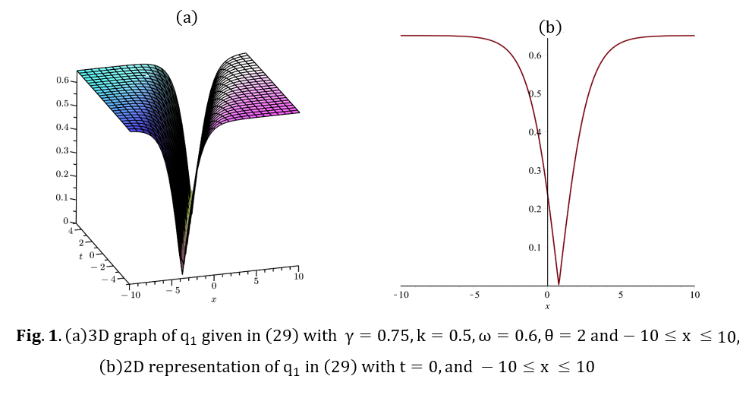

    - Cubic nonlinearity
By substituting (18-24) into the reduced equation (17), we get

$-\left[ ω-a_{1}k+a_{2}k^{2}+3 a_{4}k^{4}+35 a_{6}k^{6}\right] {csch}^{τ}\left(μ ξ\right)+\left[a_{2} +6a_{4}k^{2}+75 a_{6}k^{4} \right] τ μ^{2} \left[ τ {csch}^{τ}\left(μξ\right)+\left(τ+1\right){csch}^{τ+2}\left(μξ\right) \right]+\left[a_{4}+15a_{6}k^{2} \right] τ μ^{4} \left[\left\{τ^{3}+ \left(τ+1\right){\left(τ+2\right)}^{2}\right\} {csch}^{τ+2}\left(μξ\right)+\{\left(τ+1\right)τ^{2}+\left(τ+1\right)\left(τ+2\right)\left(τ+3\right)\} {csch}^{τ+4}\left(μξ\right) \right] +a_{6} τ μ^{6}\left[{2\left(τ+2\right)}^{2}\left\{τ^{3}+\left(τ+1\right){\left(τ+2\right)}^{2}\right\}{ csch}^{τ+2}\left(μξ\right)+\left[\left(τ+1\right){\left(τ+4\right)}^{2}\left\{τ^{2}+\left(τ+2\right)\left(τ+3\right)\right\}+\left(τ+2\right)\left\{τ^{3}+ \left(τ+1\right){\left(τ+2\right)}^{2}\right\}\right] {csch}^{τ+4}\left(μξ\right)+\left(τ+4\right)\left(τ+5\right)\left[\left(τ+1\right)τ^{2}+\left(τ+1\right)\left(τ+2\right)\left(τ+3\right)\right] {csch}^{τ+6}\left(μξ\right)\right]-2k\left(d_{1}+d_{2}\right) A^{2} {csch}^{3τ}\left(μ ξ\right)=0$
(30)

Balance the terms of the Csch functions to find $τ$ .
$3τ=τ+6$ , then , $τ=3$ (31)
We next gather all terms in Eq.(30) with a similar power in ${ csch}^{k}\left(μξ\right)$ and set to zero their coefficients to get an arrangement of logarithmic conditions the unknown's $A ,$ and μ , and solve the subsequent system:
$$\frac{52}{151}\left[a_{4}+15 a_{6}k^{2} \right]+ a_{6} μ^{2}=0$$

$\left[ ω-a_{1}k+a_{2}k^{2}+3 a_{4}k^{4}+35 a_{6}k^{6}\right]+\left[a_{2} +6a_{4}k^{2}+75 a_{6}k^{4} \right] 9 μ^{2} =0$

$4 \left[a_{2}+6a_{4}k^{2}+75 a_{6}k^{4} \right]+127\left[a_{4}+15a_{6}k^{2} \right] μ^{2}+6350 a_{6} μ^{4}=0$

$13104 a_{6} μ^{6}-k\left(d_{1}+d_{2}\right) A^{2}=0$
(32)
Solving the system of equations in (32) we get:

$μ=0.58 i \sqrt{\frac{a_{4}+15 a_{6}k^{2}}{a_{6} }}$ , $A=23.1 \sqrt{\frac{a_{4}+15 a_{6}k^{2}}{k\left(d_{1}+d_{2}\right) }}\left[\frac{a_{4}+15 a_{6}k^{2}}{a_{6} } \right]$
$ω= \frac{3.1 \left[a_{4}+15 a_{6}k^{2} \right]\left[a_{2} +6a_{4}k^{2}+75 a_{6}k^{4} \right]}{a_{6}}+a_{1}k-a_{2}k^{2}-3 a_{4}k^{4}-35 a_{6}k^{6}$ (33)
then
$q_{2}\left(x,t\right)=23.1 \sqrt{\frac{a_{4}+15 a_{6}k^{2}}{k\left(d_{1}+d_{2}\right) }}\left[\frac{a_{4}+15 a_{6}k^{2}}{a_{6} } \right]e^{i\left(-kx+ω t+ θ_{0}\right)} {Csc}^{3}\left( 0.58 i \sqrt{\frac{a_{4}+15 a_{6}k^{2}}{a_{6} }} \left( x-a_{1}+2 k\left(a_{2}+4 a_{4}k^{2}+48 a_{6} k^{4}\right) t\right)\right)$ (34)
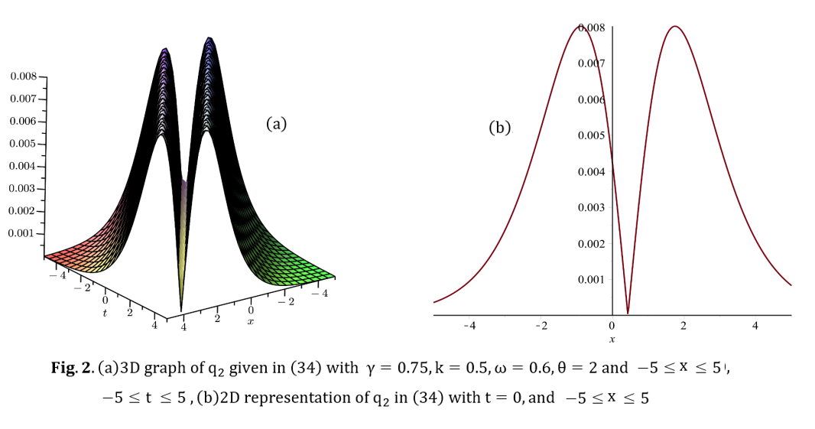

  - Sine-Cosine Method
Suppose the following solution, [12]
$u=λ \sin^{β}{(μ ξ)}$ (35)
that leads to the derivatives:
$u^{'}=λ β μ \sin^{β-1}\left(μ ξ\right) cos⁡(μ ξ)$
$u^{''}=-λ β μ^{2}\left\{β\sin^{β}\left(μ ξ\right)-\left(β-1\right)\sin^{β-2}\left(μ ξ\right)\right\}$
$u^{(3)}=-λ β μ^{3} cos⁡(μ ξ)\left\{β^{2}\sin^{β-1}\left(μ ξ\right)-\left(β-1\right)\left(β-2\right)\sin^{β-3}\left(μ ξ\right)\right\}$
$u^{(4)}=λ β μ^{4}\left[β^{3}\sin^{β}\left(μ ξ\right)-2\left(β-1\right)\left\{{\left(β-1\right)}^{2}+1\right\}\sin^{β-2}\left(μ ξ\right)+\left(β-1\right)\left(β-2\right)\left(β-3\right)\sin^{β-4}\left(μ ξ\right)\right]$
$u^{(5)}=λ β μ^{5}\cos\left(μ ξ\right)\left[β^{4}\sin^{β-1}\left(μ ξ\right)-2\left(β-1\right)\left(β-2\right)\left\{{\left(β-1\right)}^{2}+1\right\}\sin^{β-3}\left(μ ξ\right)+\left(β-1\right)\left(β-2\right)\left(β-3\right)\left(β-4\right)\sin^{β-5}\left(μ ξ\right)\right]$
$u^{(6)}=- λ β μ^{6}\left[β^{5}\sin^{β}\left(μ ξ\right)-4 \left(β-1\right){\left\{{\left(β-1\right)}^{2}+1\right\}}^{2} \sin^{β-2}\left(μ ξ\right)+3 \left(β-1\right)\left(β-2\right)\left(β-3\right)\left\{{\left(β-2\right)}^{2}+8\right\}\sin^{β-4}\left(μ ξ\right)-\left(β-1\right)\left(β-2\right)\left(β-3\right)\left(β-4\right)\left(β-5\right)\sin^{β-6}\left(μ ξ\right)\right]$
(36)

    - Cubic-quintic-septic law
Substituting (35-36) in (10), we have
$-\left[ ω-a_{1}k+a_{2}k^{2}+3a_{4}k^{4}+35a_{6}k^{6} \right]λ \sin^{β}{(μ ξ)}+c_{1} λ^{2}\sin^{3β}\left(μ ξ\right)+c_{2}λ^{4}\sin^{5β}\left(μ ξ\right)+c_{3}λ^{6}\sin^{7β}\left(μ ξ\right)-a_{6} β μ^{6}\left[β^{5}\sin^{β}\left(μ ξ\right)-4 \left(β-1\right){\left\{{\left(β-1\right)}^{2}+1\right\}}^{2} \sin^{β-2}\left(μ ξ\right)+3 \left(β-1\right)\left(β-2\right)\left(β-3\right)\left\{{\left(β-2\right)}^{2}+8\right\}\sin^{β-4}\left(μ ξ\right)-\left(β-1\right)\left(β-2\right)\left(β-3\right)\left(β-4\right)\left(β-5\right) \sin^{β-6}\left(μ ξ\right)\right]+ β μ^{4} \left(a_{4}+15a_{6}k^{2}\right)\left[ β^{3}\sin^{β}\left(μ ξ\right)-2\left(β-1\right)\left\{{\left(β-1\right)}^{2}+1\right\}\sin^{β-2}\left(μ ξ\right)+\left(β-1\right)\left(β-2\right)\left(β-3\right)\sin^{β-4}\left(μ ξ\right)\right]-λ β μ^{2}\left[a_{2}+6a_{4}k^{2}+75a_{6}k^{4} \right]\left\{β\sin^{β}\left(μ ξ\right)-\left(β-1\right)\sin^{β-2}\left(μ ξ\right)\right\}=0$ (37)

The following Lemma is needed to simplify the last equation.

Lemma 1. For any nonzero integer $β$, we have
- $7β>\max\left\{β-6, β-4, β-2, 5β, 3β, β\right\}$ , if $β$ is a positive integer
- $7β<\min\left\{β-6, β-4, β-2, 5β, 3β, β\right\}$ , if $β$ is a negative integer less than 2
- $7β=\left( β-6 \right){ ⊄\left\{ β-4, β-2, 5β, 3β, β\right\}}$ , if $β=-1$

Therefore $β=-1$, substitute in Eq. (37) to get the system of equations:

$\left[ ω-a_{1}k+a_{2}k^{2}+3a_{4}k^{4}+35a_{6}k^{6} \right] +\frac{a_{6} μ^{6}}{λ}- \frac{μ^{4}}{λ} \left(a_{4}+15a_{6}k^{2}\right)+μ^{2}\left[a_{2}+6a_{4}k^{2}+75a_{6}k^{4} \right]=0$

$c_{1} λ^{2}+200 a_{6} μ^{6}-20 μ^{4} \left(a_{4}+15a_{6}k^{2}\right)+2λ μ^{2}\left[a_{2}+6a_{4}k^{2}+75a_{6}k^{4} \right]=0$

$c_{2}λ^{4}-1224 a_{6} μ^{6}+24 μ^{4} \left(a_{4}+15a_{6}k^{2}\right)=0$

$c_{3}λ^{6}+720 a_{6} μ^{6}=0$
(38)
Solving the system of equations (38) we get:

$q_{3}\left(x,t\right)= e^{i(-kx+ω t+ θ_{0})} λ \csc{( μ \left[x-\{a_{1}-2 k\left(a_{2}+4 a_{4}k^{2}+48 a_{6} k^{4}\right) \} t\right])}$ (39)
Where:
$λ=i \sqrt[6]{\frac{720 a_{6}}{c_{3}}} \sqrt{\frac{c_{2}\sqrt[6]{{\left(\frac{720 a_{6}}{c_{3}}\right)}^{4}}+24 \left(a_{4}+15a_{6}k^{2}\right)}{1224 a_{6}}}$ , $μ= \sqrt{\frac{c_{2}\sqrt[6]{{\left(\frac{720 a_{6}}{c_{3}}\right)}^{4}}+24 \left(a_{4}+15a_{6}k^{2}\right)}{1224 a_{6}}}$

$ω=a_{1}k-a_{2}\left(k^{2}+μ^{2}\right)-a_{4}\left[3k^{2}\left(k^{2}+2μ^{2}\right)-\frac{μ^{4}}{λ}\right]+a_{6}\left[\frac{μ^{4}}{λ}\left(15 k^{2}-μ^{2}\right)-5k^{4}\left(15μ^{2}+7 k^{2}\right)\right]$

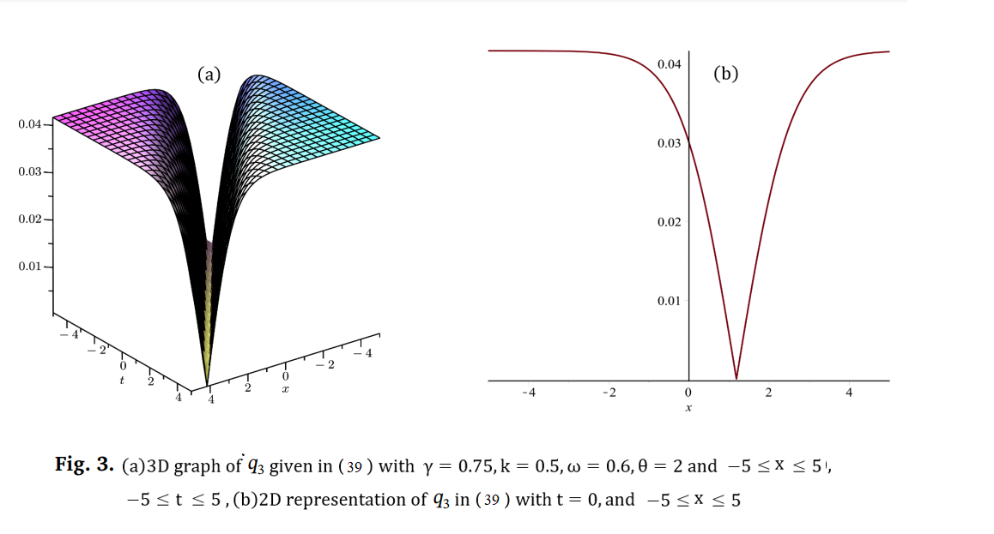

    - Cubic nonlinearity
Substituting (35-36) in (17), we have
$-\left[ ω-a_{1}k+a_{2}k^{2}+3 a_{4}k^{4}+35 a_{6}k^{6}\right] \sin^{β}\left(μ ξ\right)+β μ^{2}\left[a_{2} +6a_{4}k^{2}+75 a_{6}k^{4} \right] \left\{β\sin^{β}\left(μ ξ\right)-\left(β-1\right)\sin^{β-2}\left(μ ξ\right)\right\}+β μ^{4}\left[a_{4} +15a_{6}k^{2} \right] \left[β^{3}\sin^{β}\left(μ ξ\right)-2\left(β-1\right)\left\{{\left(β-1\right)}^{2}+1\right\}\sin^{β-2}\left(μ ξ\right)+\left(β-1\right)\left(β-2\right)\left(β-3\right)\sin^{β-4}\left(μ ξ\right)\right]- a_{6} β μ^{6}\left[β^{5}\sin^{β}\left(μ ξ\right)-4 \left(β-1\right){\left\{{\left(β-1\right)}^{2}+1\right\}}^{2} \sin^{β-2}\left(μ ξ\right)+3 \left(β-1\right)\left(β-2\right)\left(β-3\right)\left\{{\left(β-2\right)}^{2}+8\right\}\sin^{β-4}\left(μ ξ\right)-\left(β-1\right)\left(β-2\right)\left(β-3\right)\left(β-4\right)\left(β-5\right)\sin^{β-6}\left(μ ξ\right)\right] -2k\left(d_{1}+d_{2}\right) λ^{2}\sin^{3β}\left(μ ξ\right)=0$
(40)

Lemma 2. For any nonzero integer $β$, we have
- $3β>\max\left\{β-6, β-4, β-2, β\right\}$ , if $β$ is a positive integer
- $3β<\min\left\{β-6, β-4, β-2, β\right\}$ , if $β$ is a negative integer less than 3
- $3β=\left( β-6 \right){ ⊄\left\{ β-4, β-2, β\right\}}$ , if $β=-3$

Therefore $β=-3$, substitute in eq. (40) to get the system of equations:

$-\left[ ω-a_{1}k+a_{2}k^{2}+3 a_{4}k^{4}+35 a_{6}k^{6}\right] +9 μ^{2}\left[a_{2} +6a_{4}k^{2}+75 a_{6}k^{4} \right] +81 μ^{4}\left[a_{4} +15a_{6}k^{2} \right]+3 a_{6} μ^{6}=0$

$1156 a_{6} μ^{4}-34μ^{2}\left[a_{4} +15a_{6}k^{2} \right]$ $- \left[a_{2} +6a_{4}k^{2}+75 a_{6}k^{4} \right]=0$

$10080 a_{6} μ^{6} -k\left(d_{1}+d_{2}\right) λ^{2}=0$

$\left[a_{4} +15a_{6}k^{2} \right] - 99 a_{6} μ^{2}=0$
(41)

Solving the system of equations (41) we get:

$$ω=a_{1}k-a_{2}k^{2}-3 a_{4}k^{4}-35 a_{6}k^{6}+0.0288 \frac{{\left[a_{4} +15a_{6}k^{2} \right]}^{3}}{{a_{6}}^{2}}$$

$$a_{2}=\frac{0.225}{a_{6}}{\left[a_{4} +15a_{6}k^{2} \right]}^{2}-6a_{4}k^{2}-75 a_{6}k^{4}$$

$μ=\frac{1}{3}\sqrt{\frac{\left[a_{4} +15a_{6}k^{2} \right]}{11 a_{6}}}$ , $λ=\sqrt{\frac{{\left[a_{4} +15a_{6}k^{2} \right]}^{3}}{k\left(d_{1}+d_{2}\right) } }\frac{1}{ 10 a_{6}}$

$q\left(x,t\right)= e^{i(-kx+ω t+ θ_{0})} \sqrt{\frac{{\left[a_{4} +15a_{6}k^{2} \right]}^{3}}{k\left(d_{1}+d_{2}\right) } }\frac{1}{ 10 a_{6}} \csc^{3}{(\frac{1}{3}\sqrt{\frac{\left[a_{4} +15a_{6}k^{2} \right]}{11 a_{6}}} \left[x-\{a_{1}-2 k\left(a_{2}+4 a_{4}k^{2}+48 a_{6} k^{4}\right) \} t\right])}$ (42)

- Conclusion
In this paper, series of new voyaging wave arrangements have been gotten. The Csch technique as well as Sine-Cosine strategy are utilized to do the reconciliation of the resounding NLSE for AC nonlinearity with bother terms. The got arrangements are under sure circumstances and are extremely valuable and might be essential to make sense of a few actual peculiarities and track down applications in the nonlinear Development conditions.

Acknowledgment
The author(s) are significantly obliged to the reviewer for his (or her) accommodating remarks and productive ideas. This work was upheld by Al-Rafidain University College.

References
[1] Lia J, Liang JJ. Bifurcations and exact solutions of nonlinear Schrodinger equation with an anti-cubic nonlinearity. J Appl Anal Comput 2018;8(4):1194–210.
[2] Krishnan EV, Biswas A, Zhou Q, Babatin MM. Optical solitons with anti-cubic nonlinearity by mapping methods. Optik 2018;170:520–6.
[3] Zayed EME, Alngar MEM, Al-Nowehy A-G. On solving the nonlinear Schrodinger equation with an anti-cubic nonlinearity in presence of Hamiltonian perturbation terms. Optik 2019;178:488–508.
[4] Islam W, Rehman HU, Younis M. Weakly nonlocal single and combined solitons in nonlinear optics with cubic quintic nonlinearities. J Nano Opt 2017;12:1–5.
[5] Biswas A, Ekici M, Sonmezoglu A, Belic MR. Highly dispersive optical solitons with Kerr law nonlinearity by F-expansion. Optik 2019;181:1028–38.
[6] Biswas A, Ekici M, Sonmezoglu A, Belic MR. Highly dispersive optical solitons with quadratic-cubic law by F-expansion. Optik 2019;182:930–43.
[7] Biswas A, Ekici M, Sonmezoglu A, Belic MR. Highly dispersive optical solitons with cubic-quintic-septic law by F-expansion. Optik 2019;182:897–906.
[8] Biswas A, Guzman JV, Mahmood MF, Khan S, Ekici M, Zhou Q, Moshokoa SP, Belic MR. Highly dispersive optical solitons with undetermined coefficients. Optik 2019;182:890–6.
[9] Biswas A, Ekici M, Sonmezoglu A, Belic MR. Highly dispersive optical solitons with Kerr law nonlinearity by extended Jacobi’s elliptic function expansion. Optik 2019;183:395–400.
[10] Naeem Ullah , Hamood Ur Rehman , M.A. Imran , T. Abdeljawad, Highly dispersive optical solitons with cubic law and cubic-quintic-septic law nonlinearities. Results in Physics 2020; 17:103021.
[11] Anwar Ja'afar Mohamad Jawad, Mohammad Mirzazadeh, Qin Zhou & Anjan Biswas, Optical Solitons With Anti-Cubic Nonlinearity Using Three Integration Schemes, Superlattices and Microstructures journal.2017; 105:1-10.
[12] A.J. Mohamad Jawad, S. Kumar and A. Biswas, Soliton solutions of a few nonlinear wave equations in engineering sciences, Scientia Iranica D, 21(3) 2014;861-869.

